./

Learning Report –

Embedded C

Course Code: <CODE>



|  |  |  |  |  |  |
| --- | --- | --- | --- | --- | --- |
| **Ver. Rel. No.** | **Release Date** | **Prepared. By** | **Reviewed By** | **Approved By** | **Remarks/Revision Details** |
| 1 | 02-01-21 | John Wesley D |  |  |  |
|  |  |  |  |  |  |
|  |  |  |  |  |  |
|  |  |  |  |  |  |
|  |  |  |  |  |  |

**Document History**

# 

**TABLE OF CONTENTS**

Activity 1: Start up Error! Bookmark not defined.

Activity 2: LInker script 4

Activity 3: Make file 4

Activity 4: MCU specific header file 5

Activity 5: Mini project 5

main function 5

ardiuno 6

**TABLE OF FIGURES**

Figure 1: Make file 4

Figure 2: Main Function 5

Figure 3: Ardiuno Code 7

Figure 4: Output 8

Figure 5: Connections STM32F407T6 + Arduino UNO + DHT11 9

**Make file**

Link - <https://github.com/johnjw12/Embedded-C-Mini-Project/tree/main/Embedded>

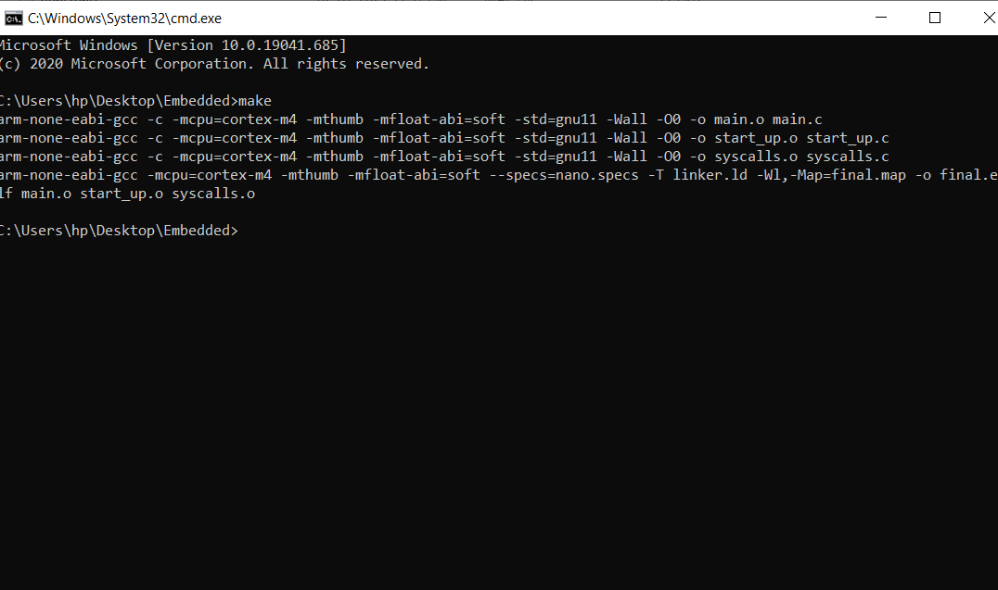

Figure 1: Make file

**MCU SPECIFIC HEADER FILE**

**Link -** [**https://github.com/johnjw12/Embedded-C-Mini-Project/upload/main/MCU-%20HEADER-%20FILE**](https://github.com/johnjw12/Embedded-C-Mini-Project/upload/main/MCU-%20HEADER-%20FILE)

**MINI PROJECT**

**Link -** [**https://github.com/johnjw12/Embedded-C-Mini-Project/tree/main/Mini%20Project**](https://github.com/johnjw12/Embedded-C-Mini-Project/tree/main/Mini%20Project)

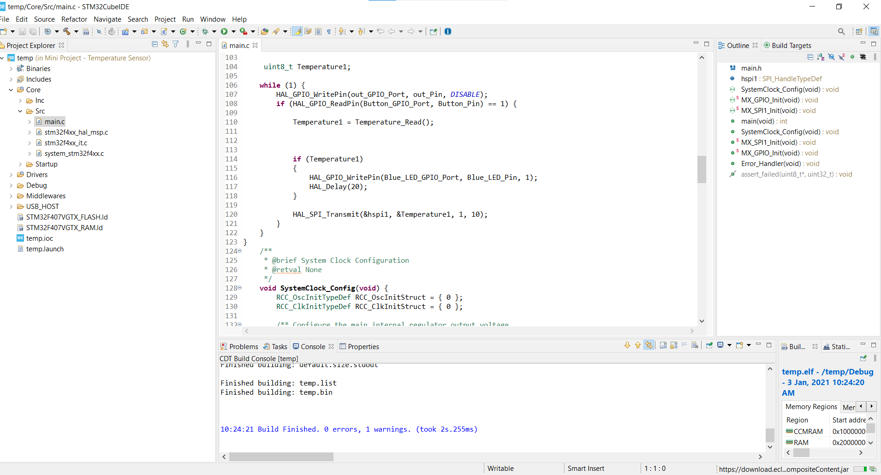

Figure 2: Main Function

**Ardiuno UNO**

**Link -** [**https://github.com/johnjw12/Embedded-C-Mini-Project/tree/main/Arduino**](https://github.com/johnjw12/Embedded-C-Mini-Project/tree/main/Arduino)

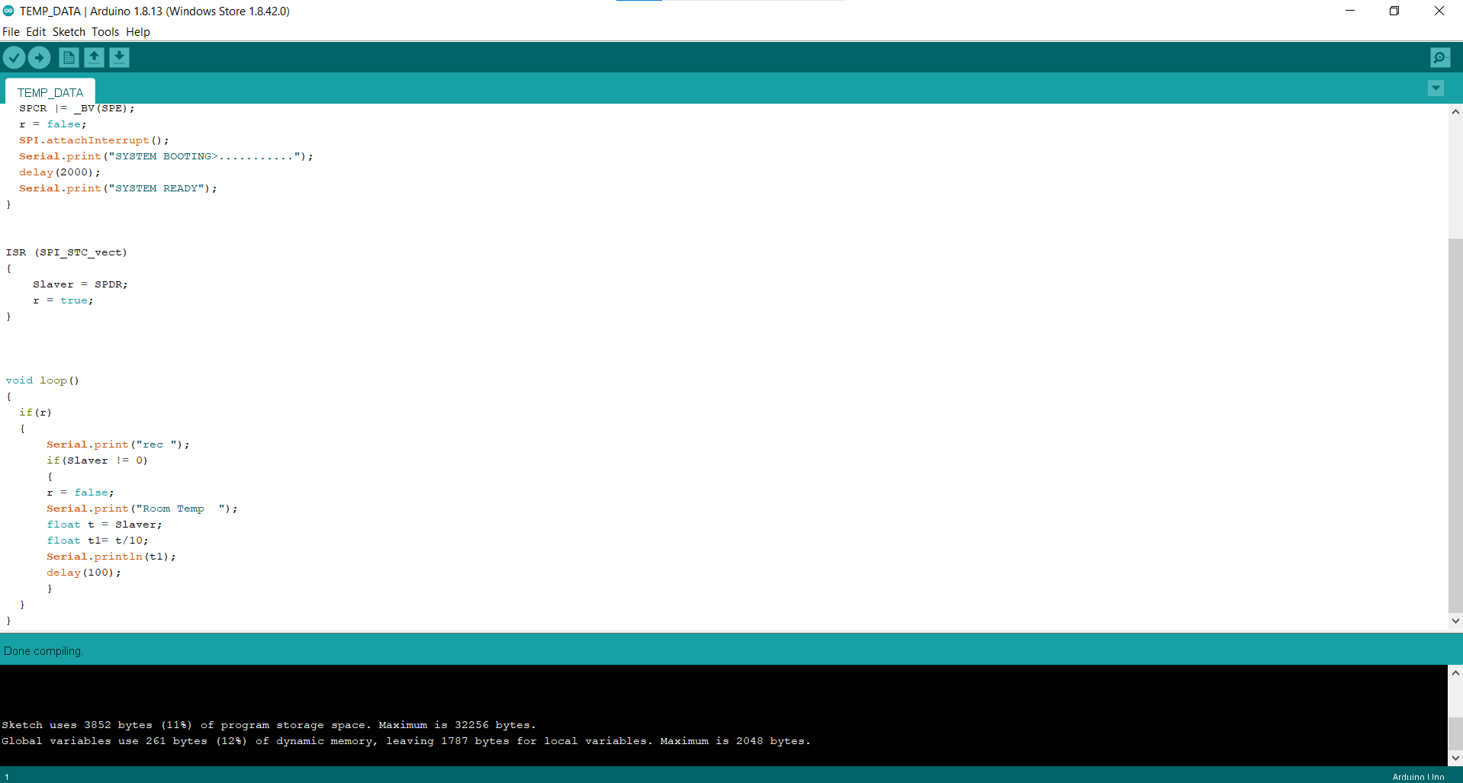

Figure 3: Arduino Code

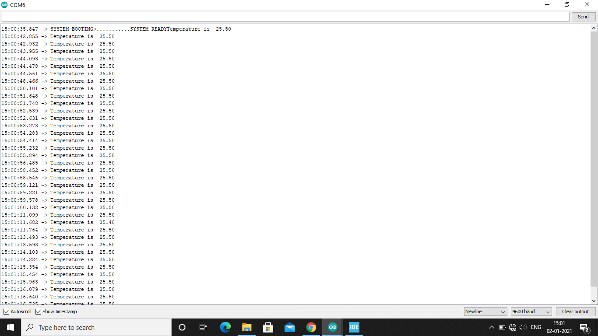

Figure 4: Output

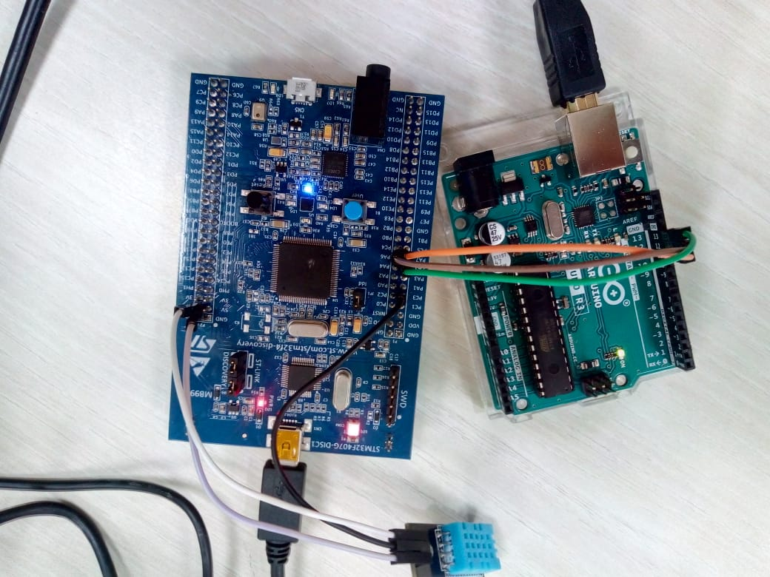

Figure 5: Connections STM32F407T6 + Arduino UNO + DHT11